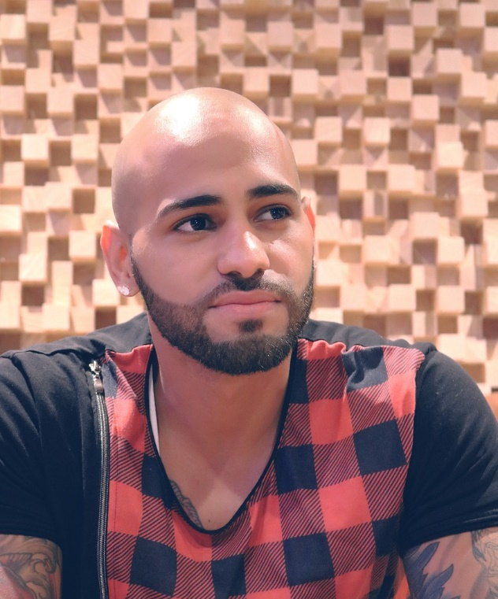

**ABDERRAHMANE**

**BIHI**

**CV**

Web developer



**DIPLOMAS Y HOBBIES**

**Formaciones :** Diplomados, Congresos, xxxxxxxxxx xxxxxx xxxxxxxxx xxxxxxxxxxxxxxxxx

**Hobbies:** xxxxxxxxxxxxxxxxxxxxxxxxxxxxxx



Sidi maarouf 6 rue 70

06 79 09 31 77

Abderrahmanebihi3@gmail.com





*PROFIL : Xxxxxxxxxxxxxxxxxxxxxxxxxxxxxxxxxxxxxxxxxxxx xxxxxxxx xxxxxxxxx xxxxxxxx xxxxxxxxxxx xxxxxx xxxxxxxxxxxxxxxxxxxxxxx.*

**COMPETENCE**

**FORMATION**

HTML/CSS

JavaScript

Bootstrap

Python

PHP

MySQL

2021  Python

Ville, Pays*Coursera (University Of Michigane)*

2021  Introduction to HTML5

Ville, Pays*Coursera (University Of Michigane)*

2020/2021  Baccalauréat PC,Phisique Chimie

Ville, Pays*Lyccé Al Bakillani*

**EXPÉRIENCE PROFESSIONNELLE**

**NOM DE L’ENTREPRISE**

Poste occupé

Tâches réalisées:

xxxxxxxxxxxxxxxxxxxxxxxxxxxxxxxxxxxxx

xxxxxxxxxxxxxxxxxxxxxxxxxxxxxxxxxxxxxxxxxxxxxxxxxxxxxxxxxxxxxxxxxxxxxxxxxxxxxxxxxxxxxxxxxxxxxxxxxxxxxxxxxxxxxxxxxxxxxxxxxxxxxxxxxxxxxxxxxxxxxxxxxxxx

**NOM DE L’ENTREPRISE**

Poste occupé

Tâches réalisées:

xxxxxxxxxxxxxxxxxxxxxxxxxxxxxxxxxxxxx

xxxxxxxxxxxxxxxxxxxxxxxxxxxxxxxxxxxxxxxxxxxxxxxxxxxxxxxxxxxxxxxxxxxxxxxxxxxxxxxxxxxxxxxxxxxxxxxxxxxxxxxxxxxxxxxxxxxxxxxxxxxxxxxxxxxxxxxxxxxxxxxxxxxxxx

**NOM DE L’ENTREPRISE**

Poste occupé

Tâches réalisées:

xxxxxxxxxxxxxxxxxxxxxxxxxxxxxxxxxxxxx

xxxxxxxxxxxxxxxxxxxxxxxxxxxxxxxxxxxxxxxxxxxxxxxxxxxxxxxxxxxxxxxxxxxxxxxxxxxxxxxxxxxxxxxxxxxxxxxxxxxxxxxxxxxxxxxxxxxxxxxxxxxxxxxxxxxxxxxxxxxxxxxxxxxxxx

Du 00/00/0000

au 00/00/0000

(Ville, Pays)

Du 00/00/0000

au 00/00/0000

(Ville, Pays)

Du 00/00/0000

au 00/00/0000

(Ville, Pays)

Français

Anglais

Arabe

**LANGUES**